Project Design Phase
Solution Architecture

Date | 29 SEPTEMEBER 2026
Team ID | SWTID-2026-5381
Project Name | AI FAQ Assistant
Maximum Marks | 4 Marks

Solution Architecture:
Solution architecture is a complex process – with many sub-processes – that bridges the gap between business problems and technology solutions. Its goals are to:
- Find the best tech solution to solve existing business problems.
- Describe the structure, characteristics, behavior, and other aspects of the software to project stakeholders.
- Define features, development phases, and solution requirements.
- Provide specifications according to which the solution is defined, managed, and delivered.

Example - Solution Architecture Diagram:

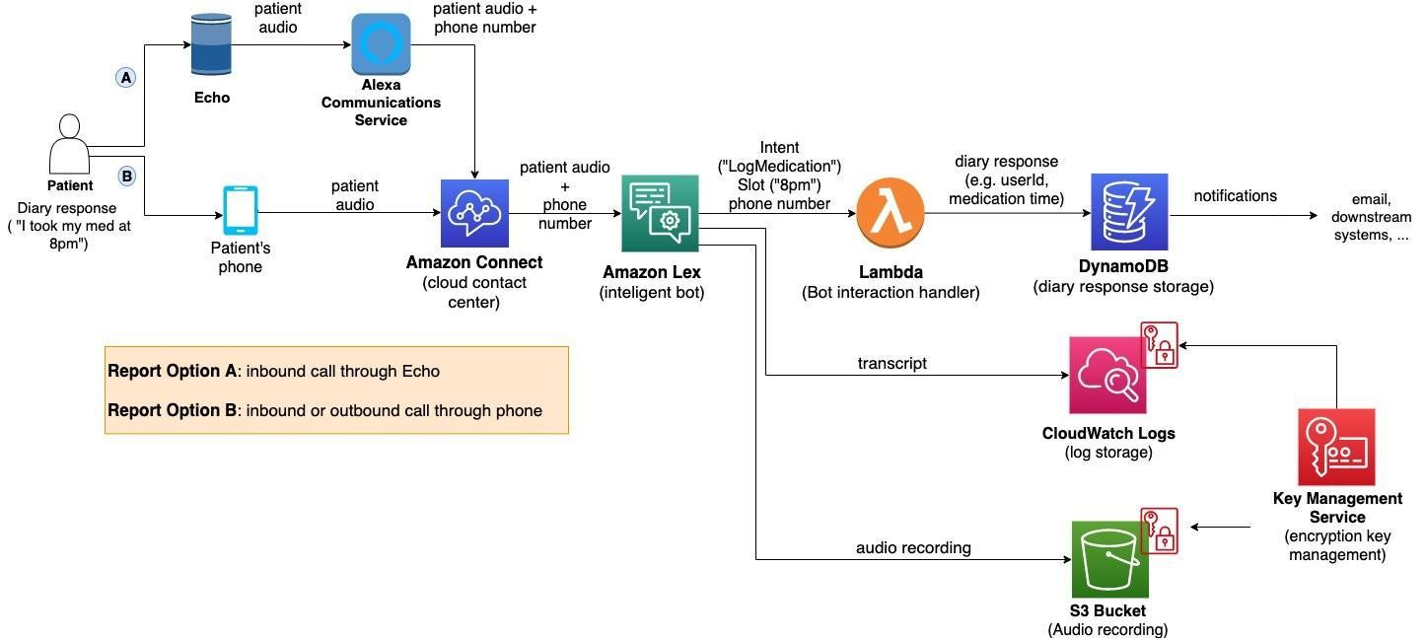
Figure 1: Architecture and data flow of the voice patient diary sample application.
User
↓
Frontend / Web Application
↓
Backend API (Node.js + Express.js)
↓
Authentication & Authorization
↓
FAQ Service
↓
MongoDB Database
↓
AI Service
↓
AI Response
↓
User

